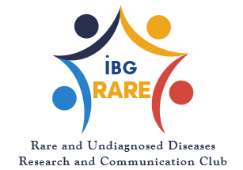

Rare Disease Reserch Image Competition

Application Form

Participant Information
Name Surname:
Study Level:
Institution Name:

Contact Information
Telephone:
Email:

Photography Information
Place and Date of Photograph taken:
Description of the photo (write a desription about photograph in your own style, consisting of 100-200 words):

I have read the conditions of participation and accept them.
I declare and undertake that I have read and accepted all the terms and conditions to participate in the photography contest titled "Capturing the Moment of Rare Disease Research" organized within the scope of "2025 Rare Disease Month" and that the photograph prepared for the contest were taken by me. that the copyright of the photograph/photographs belongs to the Law on Intellectual and Artistic Works No. 5846, other relevant legislation, and that all legal storage related to the photograph/photographs belongs to me.
NAME SURNAME: .................................
DATE / SIGNATURE: ................................

